Ernest Young
- He set the world within these walls*

by

Stephen Frost

Ernest Young B.Sc. FRGS (1869-1952), was the first headmaster of Harrow County School and held that position during the years 1911-19. Although he was headmaster for a relatively short period of eight years, his influence on the early years of the school, and its educational philosophy and values, was very significant. In this article, I will try to sketch a portrait of an extraordinary man whose life was as full, varied and fascinating as one could possibly wish for.

Early life and education, 1869-90

Ernest Young was born in 1869 in Wolverhampton, the son of Thomas John Young. He came from a modest background. His father’s occupation was stated as a commercial traveler on Young’s marriage certificate (see below). He was educated at the Stafford Street Board School in Dudley. It appears that he decided on an educational career at an early age – in 1884 he started to teach at the school that he attended. He took private classes in science and art and won prizes for his studies. He won 1st Prize in English history from the Worcestershire Union of Institutes. In 1888, he was awarded a Queen’s scholarship to study at Borough Road Training College in Southwark. He was Prize Essayist during his second year. At the start of his studies he was 28th in class, and when he left, he was 7th. He left Borough Road after two years in 1889 with his Teacher’s Certificate, and continued his studies whilst teaching at his first school.

First teaching position at John Lyon School, 1890-92

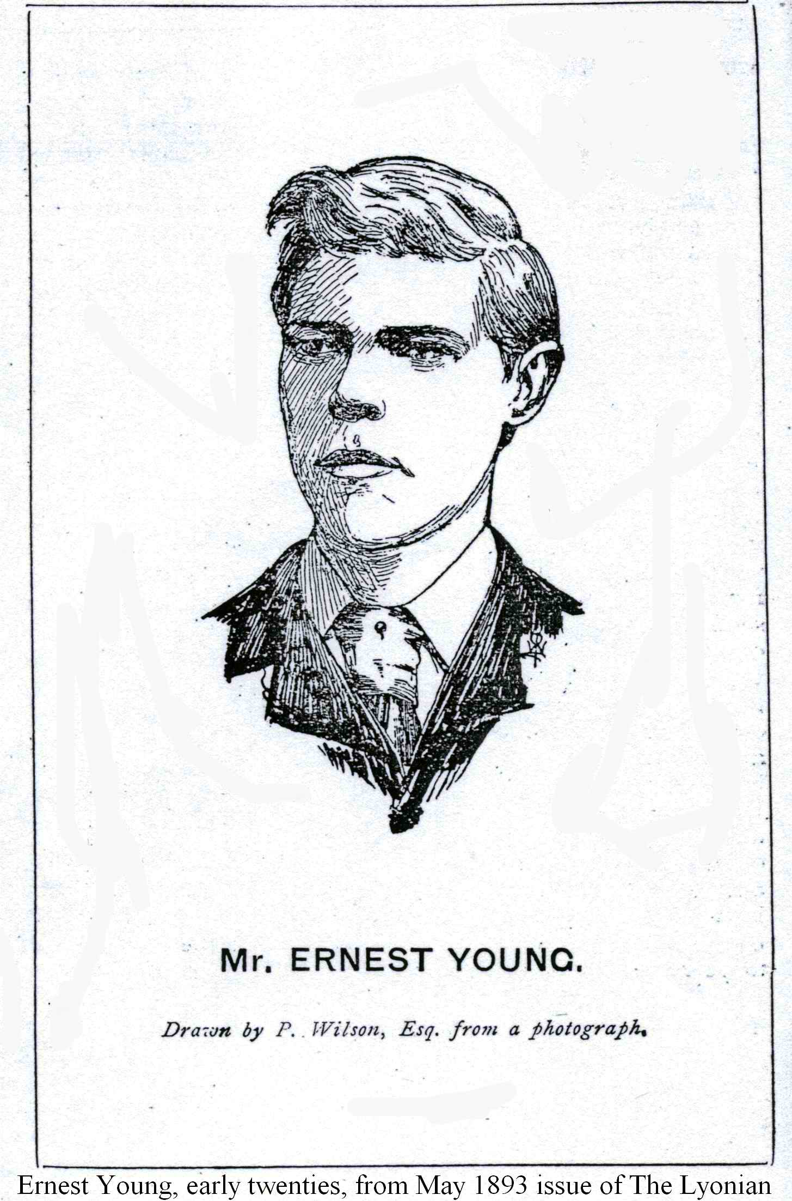
Young joined John Lyon School in 1890 at the age of 21, as science master. He laid the foundations of science teaching at the school, started the school magazine The Lyonian, and instituted an annual meeting of Old Lyonians. His ability and industry were described as ‘impressive.’ He was also appointed as temporary headmaster in the absence of the incumbent, surely highly unusual for a man of 22 or 23 with little experience, but a clear indication of his educational and administrative ability, and a precursor of his later appointments as headmaster at no less than three schools. The Lyonian commented in May 1893, after he left:

“It would be difficult to exaggerate the value of his work here, work which is still bearing fruit and will leave its mark for many a year to come. An efficient teacher, he organized our science work, founded the Lyonian, infused new life into our football, and made a healthy influence felt in every direction.”

At the same time as teaching, he completed his degree studies in June 1891, being ranked in the First Division. His Bachelor of Science degree was not finally awarded until 1901, and was issued by the London School of Economics.

Ernest Young in Siam, 1892-97

Ernest Young went to Siam in 1892 and lived there until 1897, becoming a teacher, and in 1893, the headmaster, of Suan Kularb School ("Rose Garden School") in Bangkok. This school was founded in 1882 in the Grand Palace in central Bangkok by King Chulalongkorn (King Rama V) as a school for royal children and children of palace staff. It is still open today as a boys’ only state school under the name Suan Kularb Wittalayai (“Rose Garden College”). Its pupils wear an army cadet style uniform. Seven Thai prime ministers were educated at the school, as well as numerous generals and senior military officers. It would not be unfair to describe it as the Eton of Thailand. Until recently, a photo of Young even appeared on the school website's homepage. He later worked for the recently established Education Department of Siam as an inspector of schools (the frontispiece of The Kingdom of the Yellow Robe describes him as: “formerly employed by the Education Department of Siam”).

Why would a 23 year old English schoolmaster travel 9,000 miles to work in Siam, a country whose language he could not speak, and which had little connection with England, not even being a British colony? In material I have read, it is suggested that Young met and was influenced by Sir Robert Morant, and it was Morant who recruited him to teach in Siam.

Robert Morant was one of the foremost British educators and public servants of the early twentieth century. He was born in 1863 and studied at Winchester and New College, Oxford. He completed his theology degree in 1885 and originally intended to join the church, but during his time at university, became interested in education. After leaving Oxford, he accepted a position at a school in London. He was also tutor to the children of the Siamese ambassador to England. In 1888, he traveled to Siam and accepted a position as tutor to the nephew of King Chulalongkorn, and later to the Crown Prince. The latter was aged between 10 and 11 at the time, and Morant also taught his two brothers. It is clear that he was respected and trusted by the Siamese royal family. In 1891, Morant returned to London. He had been asked by Prince Damrong, then Siamese Minister for Education, to recruit foreign teachers to teach children of the royal family. Morant recruited Young to work as a teacher in Siam. The former returned to Siam in 1892, but only remained there for a further year or so, before returning to London for good.

Morant later became a civil servant working at the Board of Education (as it was then called). He was involved with the passing of the Board of Education Act in 1899, which established a central authority for primary, secondary and technical education in England. He was also involved in the passing of the Education Act of 1902, which established local education authorities and publicly owned secondary schools (Harrow County was established by virtue of this Act). He was appointed permanent secretary of the Board of Education in 1903, and was responsible for drafting regulations to implement the 1902 Act. Morant later became the first Chairman of the National Insurance Commission. He was also involved in the passing of the Ministry of Health Act in 1919. He died in 1920.

Morant played a leading role in setting the values and philosophy of the new state secondary schools founded after the 1902 Education Act. He wanted education in the new state schools to be based very much on the methods of existing public schools, emphasizing traditional study of the humanities, and with little interest in science and technology. Young acknowledged Morant as a friend in the preface to his first book on Siam, The Kingdom of the Yellow Robe. But as will be seen below, Young’s educational philosophy was fundamentally different from Morant’s. Nevertheless, it was Morant who led Young to Siam, and it was in Siam that Young’s ideas on education started to evolve.

Young’s experiences in Siam

What did Young experience during his five years in Siam, and how did it affect his attitudes towards education? In The Kingdom of the Yellow Robe, he comments approvingly on the behaviour of Siamese children, their respectful manner towards others and lack of insubordination or impertinence. Corporal punishment was not needed in Siamese schools, because of the respect that pupils and others accorded to teachers:

“The Siamese in this respect may be said to have reached a higher level than their white brethren, in as much as they recognize… that the teacher of religion and the instructor of the young are both engaged in the same grand work of mental and moral progress.”

He praised the brightness and intelligence of Siamese children, their ability to read, write and speak English, and their retentive memories. He noted that they were naturally independent and esprit de corps had to be encouraged by the teacher in charge. Rules could be imposed not by virtue of their intrinsic value, but only if the rule was presented as a ‘European idea’, and therefore suitable for adoption and observance. Siamese children “offer to the observant master many interesting examples of the development of mind and character under a rational system of teaching.”

Reading the book gives a clear impression that Young admired and approved of the relative simplicity of daily life in Siam at that time, the gentle and polite manner of the people, their independence of character, the curious mixture of Buddhism, Brahminism, astrology, animism and superstition that makes up Siamese Buddhism, respect for the king, the practices of Buddhism, the plentiful supply of food in an agricultural society and hence lack of hunger, the reluctance to show anger or strong feelings, and other traits of behaviour that had developed in a society that had grown organically, with little contact from outsiders. The practice of Buddhism in particular appears to have fascinated Young, to the extent that he read further on the subject, and understood the four meditations, the four efforts, the four roads, supranormal powers, the seven kinds of wisdom and the noble eightfold path.

Young even quotes a translated Buddhist sermon on the duties of monkhood, which inspired the title for his book:

“He who, himself not stainless
Would wrap the yellow-stained robe around him
He, devoid of self control and honesty
Is unworthy of the yellow robe.

But he who, cleansed from stains
Is will grounded in the Precepts
And full of honesty and self restraint
Tis he who’s worthy of the yellow robe

The restrained in hand, restrained in foot
Restrained in speech, the best of self controlled
He whose delight is inward, who is tranquil
And happy when alone – him they call mendicant

The mendicant who controls his tongue, speaking
Wisely, and is not puffed up
Who throws light on worldly and on Heavenly things
His word is sweet

Let his livelihood be kindliness
His conduct righteousness
Then, in the fullness of gladness
He will make an end of grief…”

It is hard to read this without feeling that Young himself was touched by the basic tenets of Buddhism: right thoughts, right actions, self-restraint and the avoidance of anger and violence, and that this had an affect on his beliefs, and the behaviour that he expected from others. And furthermore, that the standards of conduct referred to above were suitable to be encouraged in pupils of a nascent state secondary school system in England.

Marriage, travel, writing

The illustrator for The Kingdom of the Yellow Robe and other books written by Young was Edwin Norbury. Norbury was born in Liverpool in 1849, the son of Richard Norbury RCA, and was thus 20 years older than Young. He went to Siam in 1892 to teach at the Royal School of Arts. He was an official artist for the Siamese government at the time of the Paknam incident of 1893, when a French gunboat attacked Siamese ships at the mouth of the Chao Phraya river, an event that almost led to war between the two countries. Norbury exhibited in Liverpool, Manchester and London. He was a founder member of the Royal Cambrian Academy and ran his own Norbury Sketching School and St. James' Life School in Chelsea. He was principal of the Henry Blackburn Studio. He died in London in October 1918. It is not clear exactly when Young and Norbury met. But there were few Europeans and even fewer Britons living in Bangkok during the 1890s, and one assumes that they met there after Young arrived in 1892.

On 2 April 1894, Ernest Young married May Norbury, Edwin's daughter. They were married by the Consul-General at the British embassy in Bangkok. He was 24 and she was only 17. Her father was a witness to the marriage, presumably to evidence his consent to the union since his daughter was a minor. The marriage certificate records Young’s occupation as a ‘schoolmaster’ and his father is recorded as “Thomas Young, commercial traveler.” The old register book and a copy of the marriage certificate are still kept at the embassy. Young still kept in touch with John Lyon School, and a report by The Lyonian records that on return to Bangkok from his honeymoon, a dinner was given for him and his wife by the British charge d’affaires.

As well as illustrating The Kingdom of the Yellow Robe, Norbury illustrated Young’s book on Corsica, first published in 1909, and several other books by Young. One gets the impression that Young and Norbury traveled together regularly. It is not clear whether Mrs. Young accompanied them or not.

The Kingdom of the Yellow Robe was re-published as recently as 2001, and is still worth reading today. It provides a fascinating insight into Siamese culture and society at a time when the country had little contact with the outside world. The liberal and enlightened views that Young formed on foreign peoples, and the importance of respecting foreign cultures, are very clear in his book. This is in marked contrast to the prevailing imperialist and colonialist attitudes of late Victorian England. Consider this passage from the book:

“Writers upon foreign countries generally consider it a portion of their trade to make mental if not outspoken comparisons between their mother land and the land they have been discussing, and they generally make their comparisons in favour of the former. Yet it is not easy for any man to hold the balance fairly and to say in what way a nation is wanting; for whether the comparison be of things moral or social, there arises the difficulty of fixing a standard of measurement. Morality cannot be weighed in a balance or measured with a foot-rule. What is reprehensible in one country, may be at least excusable in another.”

And in the final pages of the book:

“When speaking of the dirtiness of their [Siamese] dwellings, it would be as well to remember the slums of the great European cities, and the defective sanitation of the majority of their dwelling places. And when pronouncing judgment on the slowness with which [Siamese] education reforms are being undertaken, it should not be forgotten that we ourselves, in spite of our long educational history, number our illiterate voters by hundreds….”

“The climatic, racial and social differences between the nations of the East and West are too great to render it easily possibly for a member of either to sum up for or against the general moral condition of the other. The present writer, while believing that the evolutionary laws of growth and development apply as well to nations as to animals and plants, is well content to leave to others the task of estimating the intrinsic values of Siam’s present moral and social condition….”

Young returned to England in 1896 for a short visit, and gave a lecture at John Lyon School on his Siamese experiences. He also sent back accounts of these to The Lyonian. One of these is an account of the Paknam Incident of 1893 (see above). Young’s powers of description, attention to detail, and commentary on the morality of the dispute, are assembled with an artist’s eye for detail and with careful discussion of the moral and other issues of the conflict.

He then returned to Siam to start a Surveying School connected with the Siamese Surveying Department. There is a lack of information available concerning this period. But it would appear that he was not entirely happy in his new position, and decided to leave Siam.

Return to England, 1897

Ernest Young returned to England in 1897 and obtained a teaching position at Parmiter’s School in Bethnal Green. This appointment lasted for only a short time.

Return to John Lyon School, 1898-1910

Young rejoined John Lyon School as a teacher in 1898. During this second period at the school, his work was as impressive as it was during his earlier period of service. He encouraged the development of sound basic education. He instituted a system of monthly examinations. He encouraged the teaching of science and also of geography. A school museum was established. By 1904, a system of monthly guest lectures and concerts was started. In 1907, a Scientific Society was formed. An art gallery was set up. Regular reading habits were encouraged and development of the school library promoted. School journeys and camps were encouraged. The promotion of school camps anticipates Young’s interest in the scouting movement and the inauguration of Harrow County’s own scout troop in 1911. As well as his administrative and organisational duties, Young was still a working teacher, teaching four and a half days a week. The October 1906 edition of The Lyonian pays this tribute:

“Harrow a very great debt of gratitude to Mr. Young for what he has done during his term of office.” (Note: It should be remembered that John Lyon School is the day school linked to Harrow School, and was for many years referred to as the ‘Lower School of John Lyon.’)

In 1906, at the age of 37, he was appointed headmaster of John Lyon School. He held that position until 1910. When he left to take up the headmastership at Harrow County, The Lyonian was fulsome in its praise of his work:

“During his tenure of the headmastership of John Lyon School, he made it among the first schools in Middlesex, and the many-sidedness of his own intellect conferred upon it a further distinction. To give in detail all the many schemes and innovations that he introduced to brighten the usually drab daily round of school life would take too long, while to speak of Mr. Young’s merits as a schoolmaster would be almost an impertinence.”

Elected Fellow of the Royal Geographical Society, 1910

In 1910, Young was elected a fellow of the Royal Geographical Society. His nomination form records:

“Mr. Young is the author of “The Kingdom of the Yellow Robe (Siam)”, “Siam,” “Corsica,” “The Rational Geography” and has contributed articles and delivered lectures dealing with modern methods of teaching geography. He is a member of the Committee of the North London Branch of the Geographical Association.”

The nomination form was signed by three noted geographers:

- George Philip: Philip was a prominent geographer who founded his own publishing company which published many of Young’s geography textbooks (Note: Philip’s still exists as a publishing company today, and is part of the Octopus Group. Gaytonians in the 1960s will recall that in their first year they were required to buy a copy of Philip’s Modern School Atlas: this was published by Philip’s company. It is now in its 95th edition!)

- James Fairgrieve: Fairgrieve was also a noted geographer and writer in his own right, and joint author with Young of many school geography textbooks. He was born in 1870 in Scotland, and was thus one year younger than Young. In 1895, he graduated in mathematics from Jesus College, Oxford and later obtained a degree in geography from the University of Wales (Aberystwyeth). He first taught maths at schools in Kelso and Cambeltown. In 1899, he founded his own school in Southgate. During 1907-12, he taught at William Ellis School in North London. After 1912, he taught at the University of London Institute of Education, and also held positions in the Geographical Association. He died in 1953, only a year after Young’s death (see below).

Fairgrieve in his obituary of Young (see below) wrote that he and Young first met when Young was giving a lecture on geography, possibly at a meeting of the Geographical Association.

- J. W. Page: Page was also a geographer and wrote “Primitive Races of Today” (1938), “Man and the Earth” (1912) “From Hunter to Husbandman” (1939) and other books.

Headmaster and geography master at Harrow County School, 1911-19

In 1911, Ernest Young was appointed as first headmaster of the newly built Harrow County School for Boys. He was aged 42.

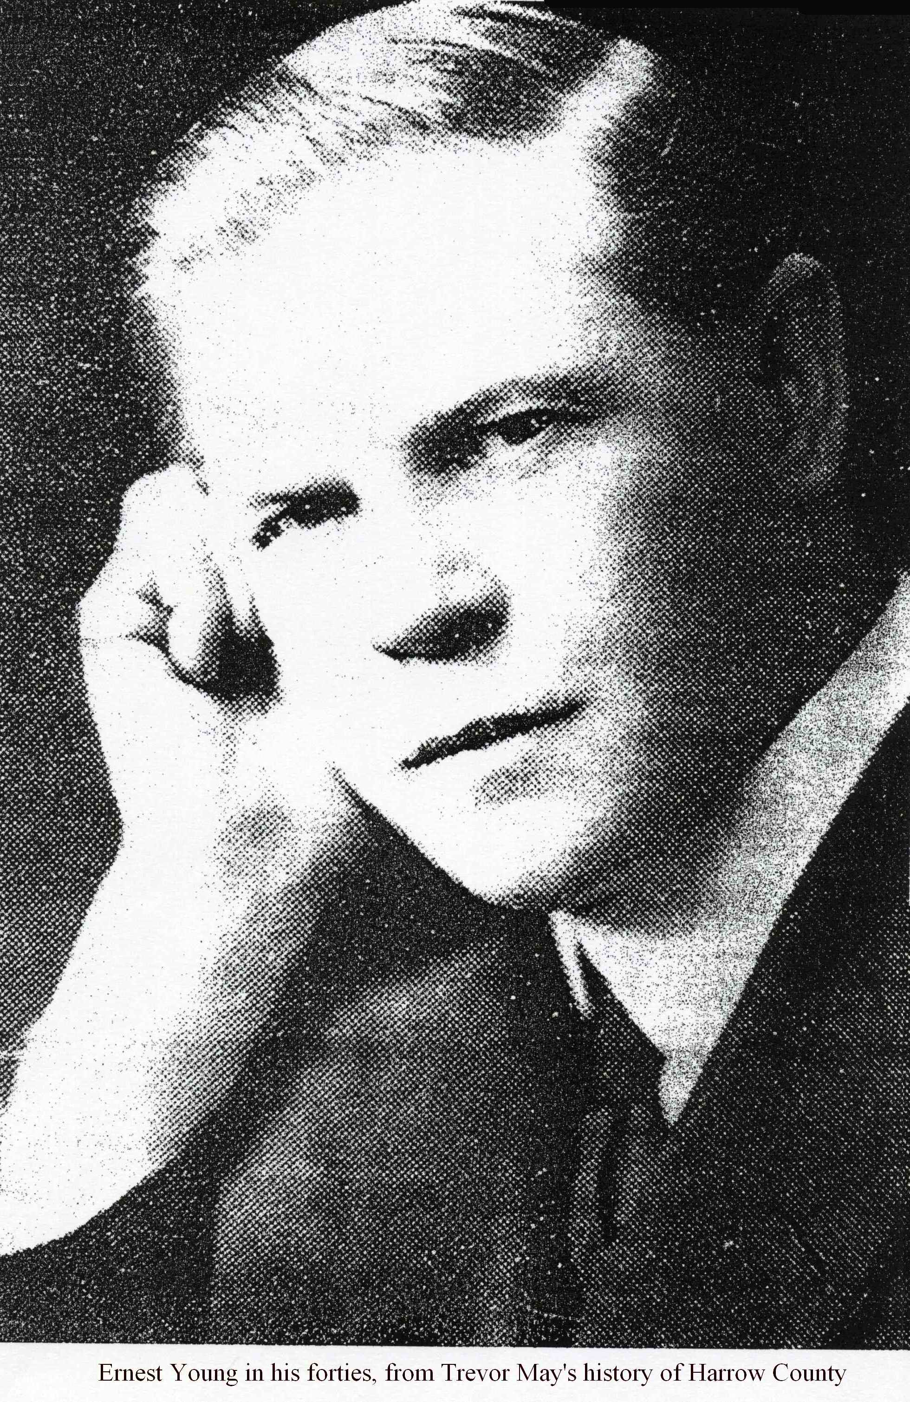
Being offered the headmastership of a brand new school with an intended compliment of 300 boys, coupled with a degree of independence encouraged by Middlesex County Council, gave him the opportunity to mold a school in accordance with his own ideas and educational philosophy. Boys would attend the school from age 10 to 16, to receive ‘a liberal and modern education.’ Places were either free, or fee supported.

Young’s priority was all round education, not merely academic education and his policy was to encourage independence and self-reliance. Prizes for academic work were limited, and competitiveness actually discouraged. No prizes were given for athletics. Personal effort was encouraged via Scout Badge work and a “commended ticket” system whereby vouchers were awarded for examination success and good behaviour, and these could be used to obtain absence from school for a day or half day. In 1913, a pavilion was built on the school field to be used as a gym, scout headquarters and old boys’ clubhouse. It was to be run by the pupils themselves. Encouragement was given to the setting up of school societies, lectures given by external speakers and concerts.

Young had a policy to recruit young (and presumably energetic) teachers (prior to the outbreak of World War One, the average age of a staff member was 26 years) with an average of only 5-6 years teaching experience. Most stayed for only a short period of time - only four of the original 18 staff stayed for 10 years or more. Only two were Oxbridge graduates, seven came from London University and four from other universities. Staff were expected to contribute fully to extra curricular activities with maximum enthusiasm, as Young himself did.

Ernest Young was an enthusiastic scouter throughout his life. He knew Lord Baden-Powell, who founded the scouting movement in 1907. Young founded the school scout troop at Harrow County in 1911 and was its first scoutmaster. Baden-Powell visited one of his first school camps in November 1911. By 1913, the school scout troop had 250 members out of 282 pupils. In a short time, the Harrow County troop became the largest school scout troop in the country. In 1914, Young was appointed as a Scouts Association examiner for Part I of the Wood Badge course for scoutmasters. In 1916, he published the first edition of “How to run a Troop” which eventually ran to 64 pages and contained a lengthy bibliography for further reading. The book sets out a training programme consisting of a 39 week course from Tenderfoot, to Second Class Scout, then to First Class Scout. The course encompassed scout law, signs, knots, fieldcraft, first aid, signaling, cooking, orienteering, swimming, map reading, map making and the training of others in these skills. In 1912, Young wrote “Adventures among Hunters and Trappers” and in 1917, a shorter version: “Daring Deeds of Hunters and Trappers,” which is dedicated to the boys of Harrow County. Both books are concerned with outdoor life and the skills taught by the scouting movement.

Parents were also expected to play a role in the life of the school. An annual parents’ night was instituted. At these, pupils’ books were put on display. Staff were required to attend and parents were allowed to question staff. Parental co-operation was expected in matters of discipline. Although Young noted “we have no corporal punishment” he once expelled a boy whose father had refused to beat him. An old boy commented “He maintained discipline by sheer force of personality. He never ranted. He never shouted.”

Ernest Young and the teaching of geography

It is important to remember that at the start of the twentieth century, the teaching of geography as an academic subject was in its infancy. The Royal Geographical Society had been founded in 1830 and had supported expeditions and explorers such as Darwin, Livingston, Speke, Burton and Scott. The Geographical Association was founded in 1893 to promote the study and teaching of geography, one of its founders being Halford Mackinder. The latter wrote a large number of textbooks on geography, and was also one of the founders of Reading University, which offered the first degree course in geography. Mackinder was also one of the founders of the London School of Economics in 1895.

It seems reasonable to suggest that Young’s interest in geography was stimulated by his foreign travels, and that after a point, the one encouraged the other. As well as his travel books, he wrote numerous school geography textbooks, the first of which was A Rational Geography written in three volumes (1908-12).

Mr. Ernest Young, Sapatoum, Gayton Road, Harrow

Sometime between 1910 and 1916, Ernest Young purchased a house in Gayton Road and named it "Sapatoum." In Thai, this means lotus pond. But I suspect that it is more likely to be a reference to Sapatoum Palace. This is a royal palace constructed in Bangkok during the reign of King Chulalongkorn in the nineteenth century. During the 1890s, when Young was in Bangkok, it was used as a palace for the king's consorts and children. In view of the small number of foreign teachers in Bangkok, and the high regard in which Young was held by the Siamese royal family, it is likely that Young taught royal children there. Sapatoum Palace is located close to Rajdamri Road, the contemporary shopping epicentre of Bangkok. It is currently used by Princess Sirindhorn, daughter of the present King Bhumibol (King Rama IX). In the choice of name for his house, Young evidently wished to commemorate his happy experiences living and teaching in Siam.

Leaving Harrow County, 1919

Ernest Young left Harrow County in 1919 after only eight years as headmaster, and when he was aged only 50. Why did he do this? The opportunity to run Harrow County in accordance with his own ideals and educational philosophy, must have represented all that he desired. Let us consider this further.

The First World War started in 1914, only three years after Young joined the school. Young’s close relationships with pupils continued when they were on active service – he kept in touch and corresponded with them (note the postcard that he wrote to one pupil, displayed on the HCS website). Sixteen old Gaytonians and two masters died in the war and others were wounded. John Boothman (later Air Marshal Sir John Boothman) whose flying achievements are commemorated in the stained glass window above the school’s main entrance, was awarded the Croix de Guerre, and other Gaytonians received awards for bravery. Many of the masters who returned from the war to continue teaching at Harrow County had been wounded or mentally scarred by their experiences. Young would have known the Gaytonians who lost their lives, or their parents, and the staff members who had died or had been wounded. Harrow County was quite small then, and these losses would have been like losing members of one’s own family. Note also that Young had no children of his own. His motivation to continue as a schoolmaster seems to have waned. He considered other careers.

In 1916, at the age of 47, Young joined the Middle Temple, hoping to pursue a career as a barrister. He completed his law studies, but was never called to the bar and never practiced as a barrister. At that time, the bar was a very exclusive profession, where connections were very important, and the risks involved in establishing a successful practice very high. To consider starting a career as a barrister at such a late age is surprising, to say the least. It is also significant to note that Edwin Norbury, his father in law, traveling companion and illustrator, died in October 1918, one month before the end of the war.

At the General Election held in December 1918, when he was aged 49, Young stood as the Liberal Party candidate for Hammersmith North. The election was won by the Conservatives with 332 seats, the Coalition Liberals winning 127, the Labour Party 57 seats, and the remainder of the Liberals under Asquith winning only 36 seats. Young lost to the Conservative candidate, coming second out of a field of five candidates. He never stood for Parliament again.

Why did Young leave Harrow County? It seems fair to suggest that the effects of the Great War, and his lack of success in establishing an alternative career, seem to have had a demoralizing effect. But it may also have been for the reason that he wanted to spend more time on his other interests: education, scouting, traveling and writing. His output of books written increased significantly after 1919.

After leaving Harrow County in 1919 at the age of 50, he never taught in a school again.

Middlesex County Council Education Committee, 1920s

Young’s interests in education, the scouting movement, and writing occupied his life during the 1920s.

After leaving Harrow County, he joined the Middlesex County Council Education Committee, eventually holding the position of Assistant Secretary for Higher Education. Young had lectured and written articles on education and educational reform during his early life. His writings on education show a considerably enlightened frame of mind, bearing in mind his formative years were in the 1880s and 1890s.

In 1922, he edited “New Era in Education,” a collection of essays written by others on many subjects, including kindergardens, boarding schools, vocational schools, outdoor schools, self government in schools and methods of study. His educational idealism shines out in his introduction:

“It would be too much to hope that those who merely regard schools as places where cheap but efficient clerks and operatives ought to be manufactured at the expense of the state, will view most of the experiments hereafter described with much favour. But those who are really serious in their wish to see a new race of citizens arise to play their part in the life of the community, will perhaps regain a little hope when they know of a few of the things that are happening in schools today.”

Young had been fighting for an educational new Jerusalem all his life, and he had no intention of compromising his ideals. He was adamant that merely copying new ideas would not work: it was individual enthusiasm that succeeded in inspiring others:

“It is not imitation that is needed, but the kindling of fires, and these are often kindled by the torch of someone else’s enthusiasm.”

Young had taken this approach to teaching throughout his career, and had encouraged those who taught with him to do so as well.

He worked at Middlesex County Council until formal retirement in 1929, at the age of 60.

The Scouts Association, 1920s

During the 1920s, Ernest Young also devoted more time to the scouting movement. Unfortunately, the Scouts Association has been unable to find any records concerning him. In addition, the biography of Lord Baden-Powell that I consulted, contains no reference to him.

During this period, he wrote a second and third edition of “How to Run a Troop” (see above), published in 1919 and 1923 respectively. During 1923-26, he was joint editor of the Scouts Association magazine The Scouter with H.G. Elwes, and sole editor during 1926-28. He became a Scout Commissioner for Education. In 1934, he was awarded the Silver Wolf, the highest award that the Scouts Association can confer.

Travel books

Ernest Young wrote travel books throughout his life. It appears that whenever he visited a country, he wrote a book on it. The travel books that I have identified are:

The Kingdom of the Yellow Robe (1898)
Siam (1908)
Corsica (1909)
Finland: The Land of a Thousand Lakes (1912)
From Russia To Siam, with a voyage down the Danube (1914)
Climbing Mount Everest by G. Ingle (as editor) (1931)
South American Excursion (1939)
North American Excursion (1947)
West of The Rockies (1949)

These books describe ways of life in those countries that in many cases no longer exist. They are invaluable for that reason, and are made further enjoyable by Young’s powers of description and attention to detail.

Geography textbooks, 1920 and 1930s

During the 1920s, he resumed writing geography textbooks, either alone or with James Fairgrieve (see above) or with Percival Rayner (see below):

Fairgrieve & Young's Human Geography (with James Fairgrieve) 2 volumes (1921)
Book I: the Life and Doings of Children in Other Lands
A Rational Geography (1923)
Human Geography by Grades (with James Fairgrieve) 6 volumes (1923-1927)
The Imperial Commonwealth Volumes I and II
Book 1 Children Far Away
Book 2 Homes Far Away
Book 3 The British Isles
Book 4 The New World
Book 5 The Old World
Book 6 Europe & Britain
The Growth of Greater Britain with maps and diagrams (with James Fairgrieve) (1924)
Children of Many Lands (with James Fairgrieve) (1927)
Homes Far Away (with James Fairgrieve) (1927)
The Gateways of Commerce (with James Fairgrieve) (1928)
Human Geography (with James Fairgrieve) (1936)
Real Geography (with James Fairgrieve) (1939)

Percival Rayner taught geography at Harrow County during the years 1913-21. He and Ernest Young collaborated on a series of five books eventually published in the 1930s:

Kingsway Social Geographies, edited by P. R. Rayner and Ernest Young (1938)
Vol 1 Hunters & Fishers by P.R. Rayner and Ernest Young
Vol 2 The Herders by P.R. Rayner
Vol 3 The Cultivators by P.R. Rayner
Vol 4 Miners & Manufacturers by P.R. Rayner
Vol 5 Traders & Carriers by P.R. Rayner and Ernest Young

The list of Young’s books above has been composed from internet sources, and may not be fully accurate, since some titles went through several editions, and other titles may have been published alone or as part of a set. Nevertheless, the total output over a period of 20 years is impressive by any standards, and evidence of the long working relationship between Young and Fairgrieve.

More traveling, 1930s and 1940s

Ernest Young continued to travel during the 1930s and 1940s, when in his sixties and seventies. In 1939 when he was aged 70, he took a ship from Liverpool and travelled across North America from Quebec to San Diego, and also traveled in South America. These journeys resulted in the last three titles referred to in the penultimate section above. The Royal Geographical Society retains a number of photographs taken by Young during his travels in the United States during this period.

In particular, the RGS holds a photograph of him taken in California in 1942, when he would have been 73 or so.

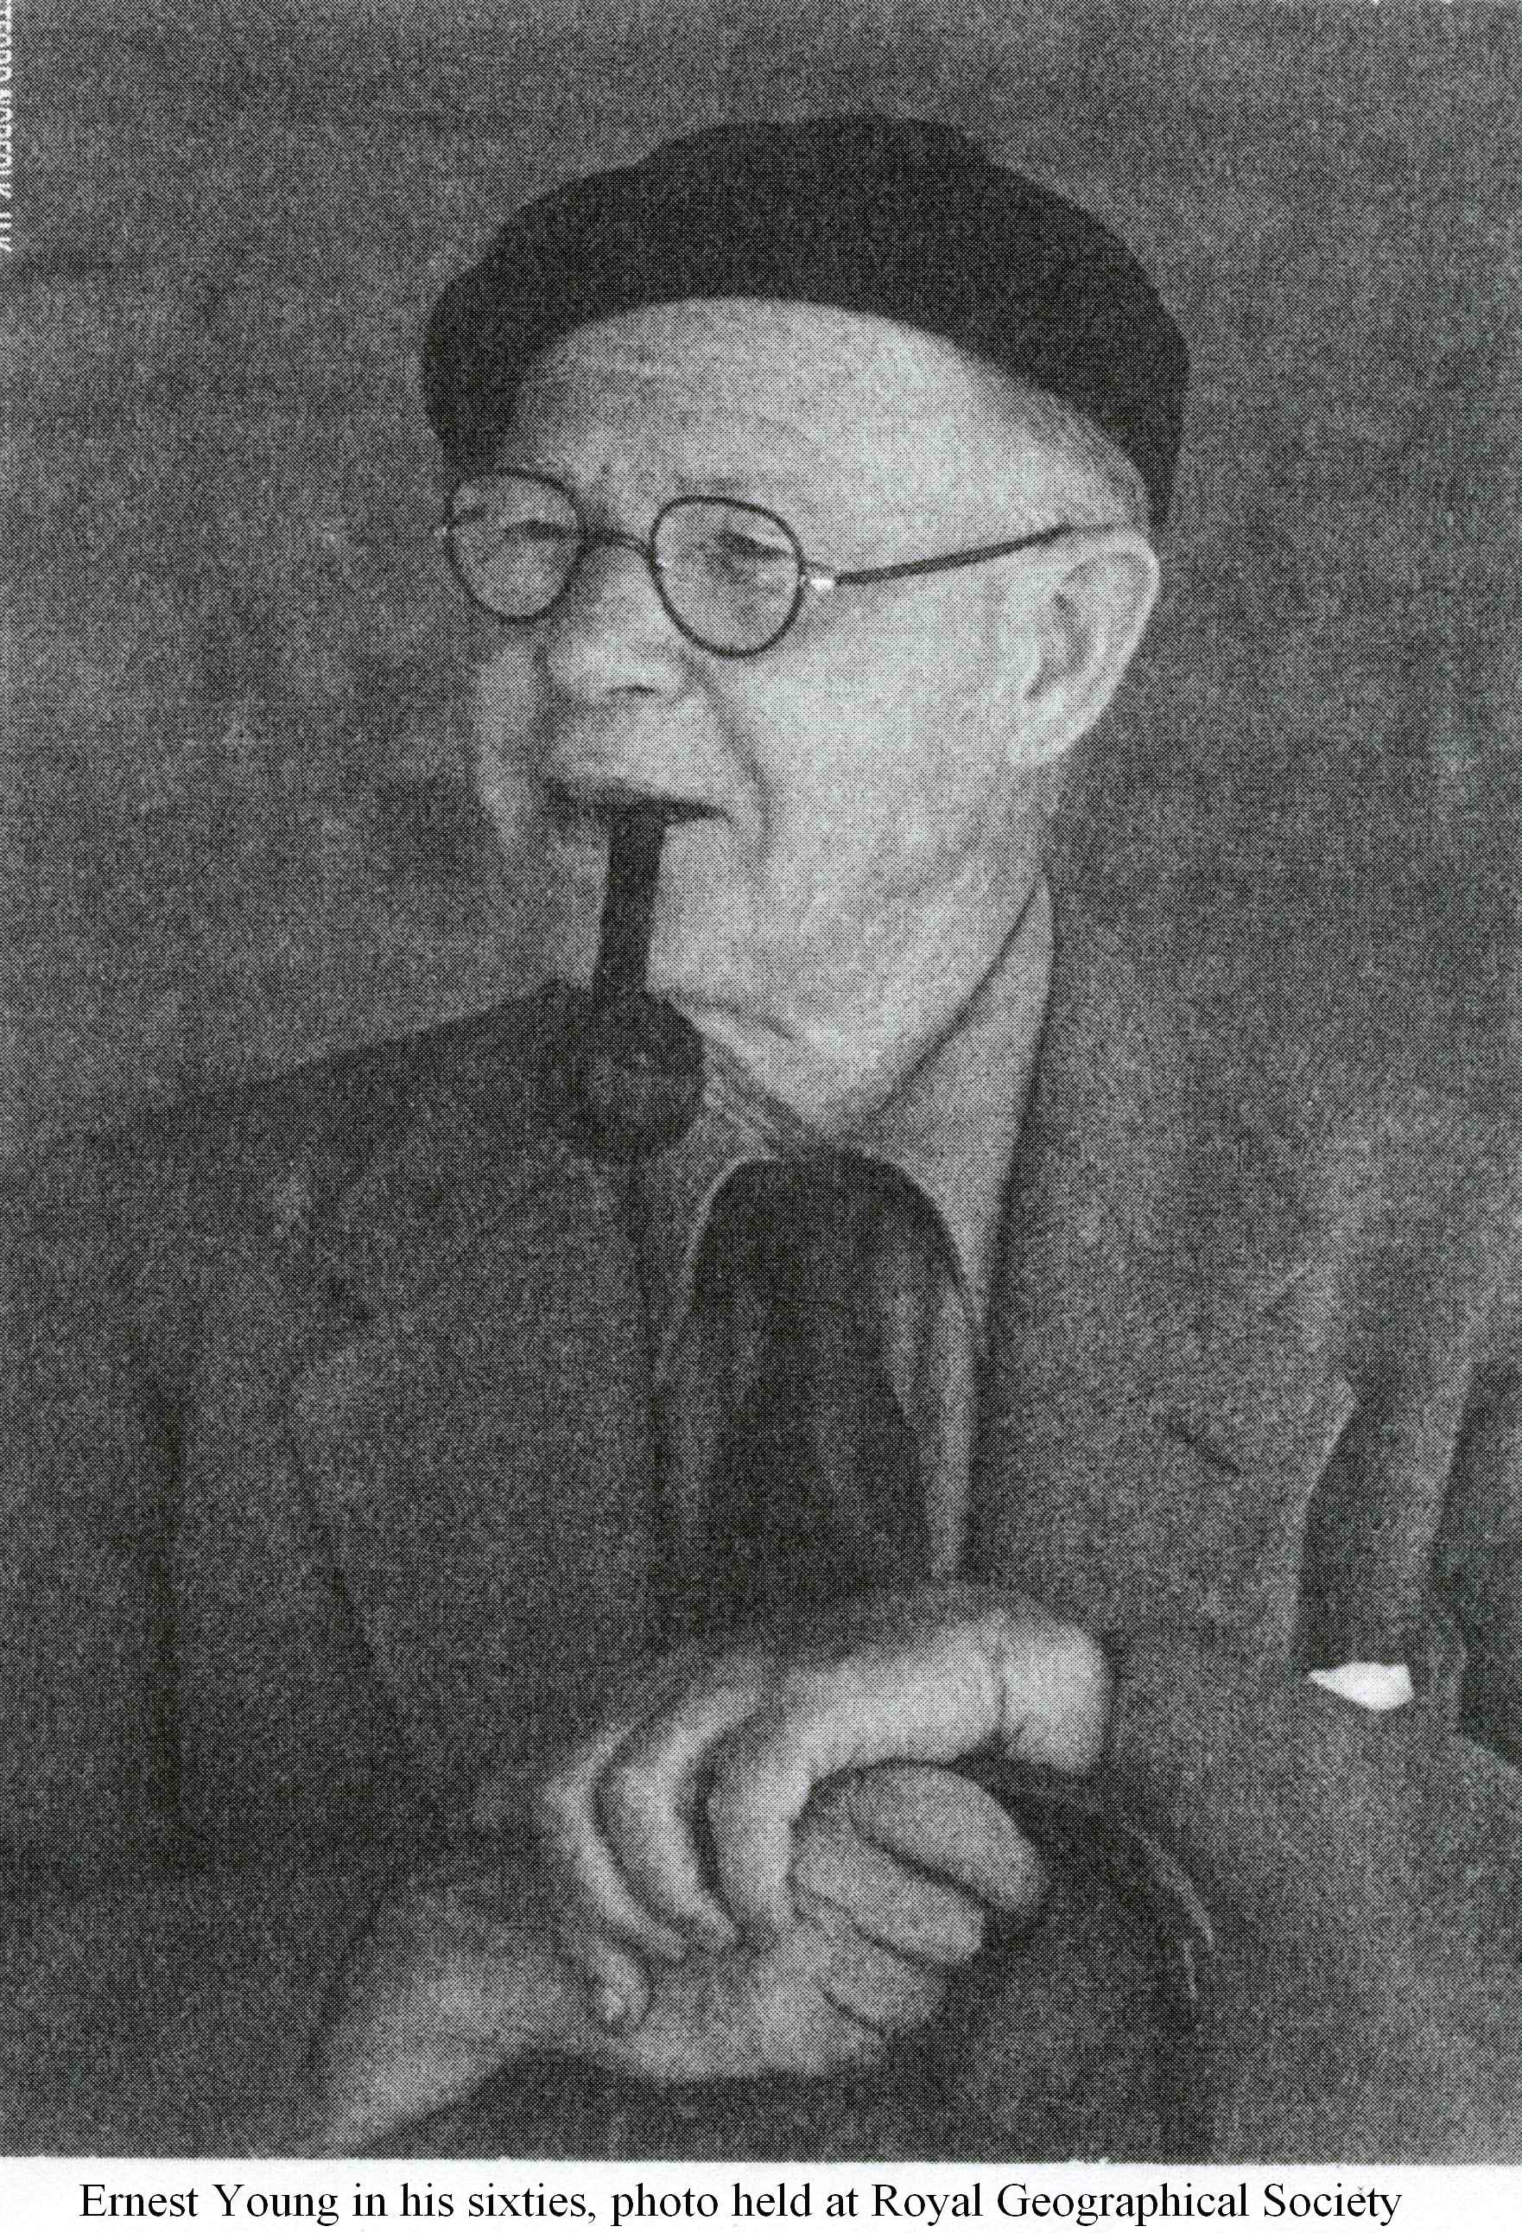
A smiling public man wearing the quiet dignity of old age.

Death, 1952

Ernest Young died on 10 February 1952 at the age of 82, after a short illness. He had suffered with diabetes for many years. His wife pre-deceased him. They had no children. James Fairgrieve wrote a warm and appreciative obituary of him in Geography magazine of April 1952. How does he remember Young?

“In all the forty odd years that I knew him I never saw him angry or even mildly cross…All his life except when he was headmaster he was continually on the move and whatever he did or wherever he went he wrote a book. Everywhere he went he made friends. Like another traveler he was a friend of all the world… He had a great zest for life…”

He also comments on Young’s travel books:

“I do not know of any books quite like them. They are interesting records of travel by one who notices things and people, but many of the things he notices are not usually noticed. …They are full of just the kind of things that the good geography teacher wishes to know. There are many travelers and many good geography teachers, but very few are both. Young was one of the very, very few.”

Fairgrieve himself died only a year later, in 1953.

Conclusion

Ernest Young was a highly intelligent, multi-faceted man, and the possessor of a restless personality and intellect. He was a liberal and progressive teacher and educator who lectured and wrote on educational reform. He was the headmaster of not one, but three schools: two in London, and one in Siam. He was an accomplished writer with a prodigious output of travel books, school geography textbooks, and other books on scouting and education to his credit. He visited many countries during his lifetime, and the books that he wrote on those countries are as interesting today as when they were first written. At the age of 47, he read for the bar. At 49, he stood for Parliament. He worked as an educational civil servant, and as a journalist with the Scouts Association. He was still travelling abroad and writing when in his sixties and seventies.

What an extraordinary and fascinating man he was.

Stephen Frost (HCS 1963-70)

Notes

In writing this article, I would like to express my appreciation for the encouragement and comments of Jeff Maynard, the HCS site webmaster, and Alex Bateman, school archivist. The key written work on Harrow County is Trevor May’s “The History of Harrow County School for Boys,” and I have quoted liberally from it in this article. I also contacted many organizations, including: the Old Lyonians’ Association, the Society of the Middle Temple, London University, the Royal Geographical Society, the Geographical Association, the Victoria and Albert Museum, the Scouts Association, the Liberal Democrat Party, the British Embassy Bangkok, and Suan Kularb School, Bangkok, and received as much assistance as they could give. And of course, the ubiquitous Mr. Google also played a part. To all of them, I express my gratitude.

* At the top of the staircase at the main entrance to Harrow County, close to where the war memorial is located, is a brass plaque that reads as follows: ERNEST YOUNG THE FIRST HEADMASTER OF THIS SCHOOL LOVER OF HARROW Geographer, traveler Author. Friend of “B.P.” (Lord Baden Powell) HE SET THE WORLD WITHIN THESE WALLS

