THE SCHOOL WAR MEMORIAL

Harrow County Grammar School for boys was only three years old when the First World War erupted across Europe in 1914. The school itself was coming to the end of its summer holiday, and in fact a party of Scouts from the school troop, consisting of eight boys and two Masters, was just about to embark on a short tour of southern Germany. The trip started well, but within a few days, things had become chaotic. They began to encounter formations of soldiers, and often at places they stopped, the only food available was for the German military. A decision was made to return to England, and after a longer return trip through the Rhine Valley, the Scouts caught the last train bound for the Belgian border, which they crossed at about midnight. They found out later that it had been closed only two hours after they left. Arriving back on the Sunday evening, one of the boys later noted that in the proceeding four days, they had slept properly only twice, and had had only two good meals.

From the start, many young men were caught up in the euphoria of fighting for 'King and Country' and took the shilling, a way of enticing them into joining the armed services. From the school, 189 former pupils and Masters answered the call, joining up from 1914. This included many sets of brothers, and more than one who was under age. Of the original school roll of 75 boys, all but 12 saw service during the war, as well as 5 of the original 10 Masters. Of that number, 16 boys and two Masters did not live to see the armistice of 1918, including the twin Bowick brothers.

The Great War, or 'The War to end all Wars' as it became known, had a profound effect on some of those who did return. Douglas Imrie, a Master, left the school only a year after returning, his health broken. Another, Frank Petterson never returned to Harrow County, while four others left teaching altogether. James Paterson gave up teaching after three months, while Charles O'Sullivan, known to most boys as 'Sully', lost a leg. He later began returning to the school in the evenings to play the piano for hours at a stretch. Some thought it was the result of the shock of losing his leg.

In 1920 thoughts turned to a memorial in the school to honour those who had given their lives in the service of their country. A meeting was called by the Headmaster, Randall Williams in July 1920, and a committee formally set up to oversee this. The Chairman was Mr C H de Wilde-Green, and the Treasurer Mr G H Beet, both of whom had lost sons, while the Secretary was Mr C A Knowles who had himself been an old boy who had served. An appeal for donations was made, with the response so great that by the Spring Term of 1921, the new memorial was ready for unveiling.
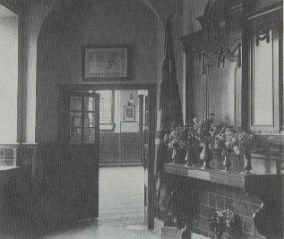

The War Memorial in its original position, just inside the main entrance
This was done on the evening of Tuesday 22nd February, 1921, by Mr Ernest Young, who had been Headmaster of the school from its opening in 1911 until 1919, and dedicated by the Venerable C E Lambert, Archdeacon of Hampstead. After a short service, and a reading of the names, Archdeacon Lambert spoke the following words:-

''To the glory of God and in grateful memory of those of this School who gave their lives for King and Country and a righteous cause, I dedicate this Memorial. May all who look upon it realise the peace of sins forgiven, the joy of fruitful service, and the power of the endless life, to which God vouchsafe to bring us all; through Jesus Christ our Lord''

The original memorial cost £120, and was made locally by the Forward Cabinet Works in Wealdstone under the supervision of Mr Green. It consisted of a carved oak base containing three rolled brass panels, bearing an inscription, and the names of those who died. The base had two brass flag holders, and an area to place flowers, and the whole was situated in the entrance hall, to the left of the main staircase. Flanking the stairs on either side, was the Roll of Honour, an illuminated roll of names of all those from the school who had fought during the war. Most were written in black, with those who did not return being written in gold. Above the staircase was placed a carved panel bearing the school crest and dates 1914-1918.
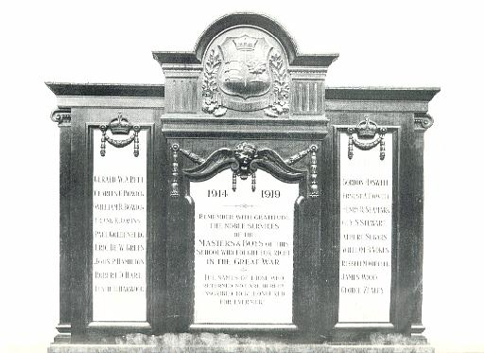

The panels of the original memorial

A School Remembrance Day service, held on the school day nearest to Armistice Day (November 11th), was begun in November 1919, when the names of those who died was read out, and a selection of hymns sung. Wreaths were also laid on the memorial, by representatives of the Scouts, Staff, Old Gaytonians Association, and Prefects, while a scout Colour Party would also march down to the Harrow Town memorial, at the foot of Harrow Hill to lay wreaths.

The Memorial is moved

In early 1932, to mark the 21st anniversary of the Old Gaytonians Association, it was decided to re-site the memorial, from the main entrance, to a more suitable location at the head of the main staircase. Some rebuilding was needed, both inside and out, and so the Mothers Sewing Party took on the task of raising the necessary funds needed. Permission of the local Governing Body and Middlesex Education Committee was sought and obtained, and consultations began with the County Architect.
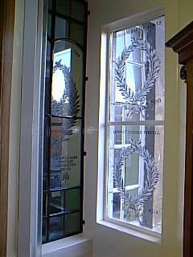

Despite the fact that the new location involved considerable difficulties, the work was successfully undertaken by Messrs. Collins and Charles. Placed directly above, was a stained glass window in the form of the school badge, while further down, two smaller windows were incorporated depicting the Scout emblem and St. George's Cross. These were designed by Mr E F Beckett, a long time friend of the school, and creator of the illuminated First World War scrolls which flanked the foot of the stairs. Behind it, several memorial windows bearing the names of some of the dead were placed. (It is believed that these were donated by individual parents). A new oak table was also included, a gift of Mrs C H Green in memory of both her son Eric, and her late husband who had been Chairman of the original War Memorial Committee. This was constructed by the same local company responsible for the original memorial. Outside, stone columns and a new façade, in keeping with the appearance of the existing buildings was constructed, bearing bronze numerals '1914-1918'.
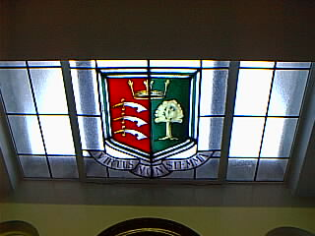
(left)The main stained glass window, and (right) some of the individual memorial windows on the memorial

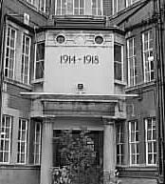
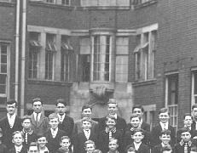
(left) The original windows on the main stairs, seen in June 1922, and (right) the same view of the new memorial after its relocation in 1932.
The 'new' memorial was ready to be unveiled on November 11th 1932. After a service in the school hall, parents, staff, the school choir, and a Scout colour party gathered at the foot of the stairs to officially dedicate the memorial, and to lay wreaths. One reason that particular site had been chosen was that the outside wall of the memorial faced the school field. The Vicar of Harrow, Rev. E Stogdon, who conducted the memorial service made reference to this with the words, "…may this memorial, facing the playing field, serve to remind the School at all times of the heroism of those who, having played as boys on its field, went out to the field of battle and died as men for their country…"
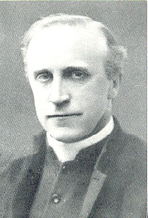

The Rev. E Stogdon

War Clouds Gather Again

In late 1939, war clouds again began to gather, and on September 3rd, Britain declared war on Germany, the Second World War had begun. The school had grown since it was first built, and the number of pupils had increased. However, only four members of staff were called up, being so in 1939, 1940, and 1942. In February 1941, the school had formed one of the first units of the Air Training Corps (A.T.C.), with the result that, of the numbers going into the forces, a majority who had been members joined the Royal Air Force. In all, over a thousand boys served, and of that number, 142 lost their lives, including two sets of brothers. The first of these was Ordinary Seaman Edward Williams, who drowned after his ship, HMS Rawalpindi was sunk by the German battleship 'Deutschland' on November 23rd 1939. He was 19, and had joined the Navy only 3 months before. Another former pupil, Kenneth Kocher died in February 1941, when his Merchant Navy ship was sunk. He was just 16.
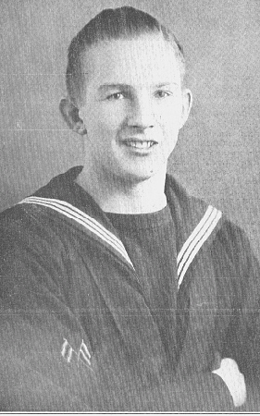

A list of those members of the school serving in the forces was published in the regular 'Gaytonian' magazine published within the school. This had been done during the First World War, and was updated as time went by. As news came through of awards or deaths, these details were also included. Old Gaytonians served in every theatre of war, and in every service. At least two served in the Australian Army, one in the New Zealand Air Force, one in the Turkish Army and one in the German Air Force. The latter, known only as 'Muller', had been educated at Harrow County, as his father worked in London before the war. Later on, whilst flying as a navigator in a JU88 aircraft, he was shot down and captured. The pilot who did so, Freddie Green was another Old Gaytonian, who after landing, met his foe. As they were talking, an Army patrol turned up to take Muller in to custody, and there was disbelief all round when the Officer leading them turned out to be another old boy of the school, Lt C W Stevens.
Edward Williams, the first casualty of the Second World War

The decision to add to the memorial the names of those who died during World War Two was an inevitable one. It was decided to have two new panels made to accommodate these, in the same style as the original memorial, and also to have a Book of Remembrance made, containing the names of all those who died during the two wars. In addition, a new centre panel on the original memorial was made, to include the dates '1939-1945'. The new brass panels were framed in oak, and hung on the walls on each side of the memorial, while a glass topped display case was made to house the book. This new look memorial was unveiled and dedicated on Wednesday, December 8th, 1948, by the Rev. Randall Williams, who had been Headmaster of the school between 1919, and 1945.
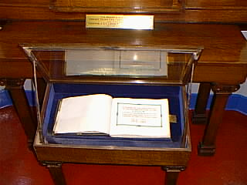
The Book of remembrance in its display case

Post-War and National Service

The end of the war did not see the end of compulsory military service in Britain, and young men continued to be drafted into the forces. A number of old boys were killed in the years following the war, mostly in training accidents. A further panel to include these names was introduced, and kept up to date until the early 1950's.
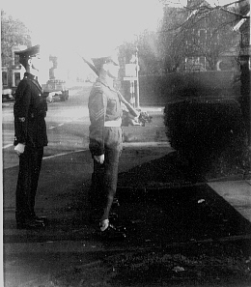
HCS Cadet Colour Party marching from the school along Kenton Road to lay a wreath on the original Harrow Town Memorial at the foot of Harrow Hill, and the service (1960)
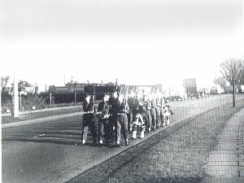
The original A.T.C. unit had been disbanded in 1947 to make way for a new Combined Cadet Force (C.C.F.), and on Armistice Day a cadet colour party would
march to the Harrow War Memorial, located at the foot of Harrow Hill, to lay wreaths, and conduct a short service. A representative of the C.C.F. also joined with
those others to lay a wreath on the school memorial.

In 1994, a new Headmaster joined the school (Mr Martin Buck), but to the dismay of many, decided to disband the C.C.F. Along with the School Scout Troop (4th Harrow, who by this time existed outside the school), they had formed a colour party and taken the salute each Remembrance Day, as well as providing a Guard of Honour by the memorial. It was also decided, after 76 years, to end the annual 'Service of Remembrance', and replace it with a 'Service of Reflection', to reflect more closely the changing face of the school and its multi-national make up. This move upset many members of the Old Gaytonians Association, some of which had brothers or other relatives mentioned on the memorial. The 1932 'Book of Commemoration' (written on the school's 21st Anniversary) mentioned that "It is to be hoped that the Service…will continue to be one of the best traditions of the school".

More Changes Take Place

With an extensive rebuilding programme in the school underway in the late 1990's, it was decided to remove the remaining sections of the original memorial, comprising the First World War illuminated Roll of Honour, from the foot of the main staircase and re-site them. The two side panels were moved to the landing by the main memorial and hung on the wall next to the brass panels bearing the names of the Second War casualties. The oak panel surmounting the staircase was also resituated, at the top of the stairs, and new lighting was added to highlight this. For some reason, the brass panel containing the names of the post-war dead, removed to make space for the First War panels, was not replaced anywhere on the memorial.
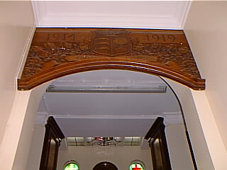

The oak panel dating from 1921, in its new position at the top of the main staircase

The school changed once more in 1998, to become Harrow High School. The following year the 'Old Gaytonians Association' were invited back to have their own service at the memorial, and to later join in with the school service. Some 20 members enjoyed the gracious hospitality of the school, and it is hoped that this association between the Old Gaytonians and the school will continue and grow.
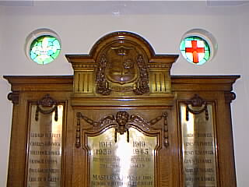
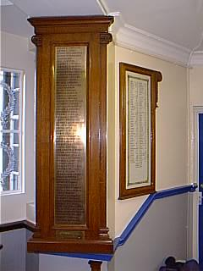
(Above) The two stained glass windows above the memorial; and (left) a view taken on the landing by the memorial, showing the memorial windows to the left, the Second World War brass panel in the centre, and to the right, one of the original First World War illuminated scrolls, previously at the foot of the stairs (November 2000).

In mid 2000, a project was begun, to research as fully as possible, those members of the school who gave their lives in post-war conflicts, with the intention that they will be added to the memorial, and the school's Book of Remembrance, by November 2001. The brass panel containing the post-war names, removed a few years before, will be restored to the memorial and updated with the additional names.

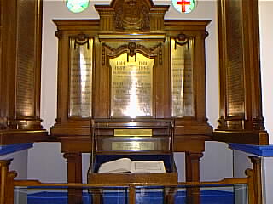

The War Memorial in November 2000

With later extensions to the school (completed in the early 1950's), the playground area behind the main buildings became closed in, forming what became known as the 'Inner Quad'. Therefore the view from the memorial to the school field was obstructed.
Although the memorial and Book of Remembrance contained the dates '1939-1945', they both contained the names of 3 boys killed just after the war, up to the unveiling of 1948.
This tradition which had begun with the School Scout Troop many years before, ceased in the mid 1970's when the school, and cadet force reduced in size on the occasion of the school changing from Harrow County to Gayton High School.
It was agreed by the Committee of the Old Gaytonians Association that certain criteria should first be established. These were a)Those who died whilst a member of His/Her Majesty's Armed Forces, either on Active Service, National Service or whilst training or engaged on other official duties; b)Those who died as a result of illness or injury whilst a member of His/Her Majesty's Armed Forces; and c)Any member of the school (staff or pupil) who have died as a direct result of war. This encompasses those names already on the memorial.

