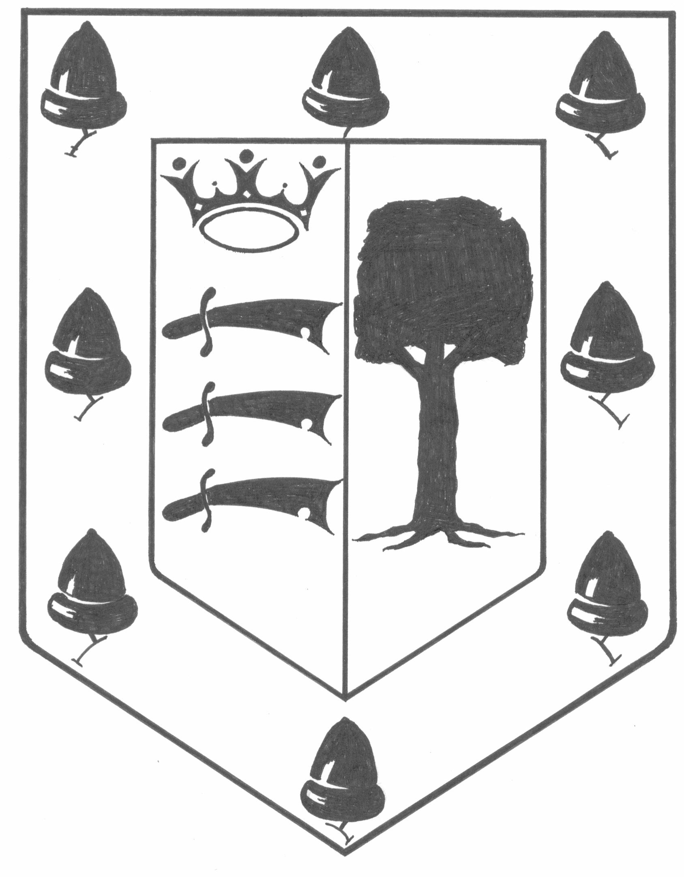
OLD GAYTONIANS ASSOCIATION

MEMBERSHIP APPLICATION

Membership of the 'Old Gaytonians Association' is open to any former pupil of Harrow County, Gayton High, Harrow High and Gunnersbury Schools. Present and former members of staff of the schools, and blood relatives are also eligible for membership.

Annual membership is currently £10:00 for adults, or free to YOGAs of 21 years or under, payable on the 1st of October. (Payment can be made by Standing Order, or cheque. Please make cheques payable to ‘The Old Gaytonians Association’).

(Standing Order only)

* To:- (Bank)
(Branch)

(Account Number)

Please pay to the National Westminster Bank PLC, 315 Station Road, Harrow, MIDDLESEX (Code No. 60-10-10) for the credit of the Old Gaytonians Association (Account No. 19291876) the sum of £10:00 (ten pounds) now, and continue to pay that sum annually on the 1st of October until further notice.

I enclose a cheque for £10:00 (ten* pounds).

I am under 21 years of* age (no charge).

Please send me………….Association* tie/s* at £6:00 (six pounds) each.

(*Tick or delete as appropriate)

Name: (Block Capitals)

Address:

Date of Birth:
Email Address:
Dates at School (if applicable):

Signature:
Please return this form to:-

Bob Smith
1 Crosier Road, Ickenham, Middlesex, UB10 8RR. U.K.
(email: bob1crosier@blueyonder.co.uk)

(Data Protection Act: The Old Gaytonians Association maintains computer based and manual records containing information about members. This information is accessed and used solely by Association Officers in connection with Association business. No information will be disclosed to a third party without your consent.)

